5th Annual Gulfcoast Orthopaedic Rehabilitation Conference

Hyatt Regency, Sarasota, FL, August 25 2018

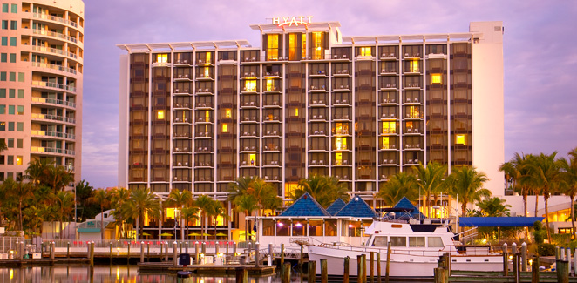
The Gulfcoast Orthopaedic Rehabilitation Conference is an event designed to bring orthopaedic surgeons, physical and occupational therapists together in an educational forum. Through a series of didactic lectures, leading area surgeons will discuss the treatment of various upper and lower extremity conditions and the role physical and occupational therapy plays in the management of these disorders. Multiple panel discussions allow for the therapists to interact with the surgeons in an effort to have open question and answer sessions between sets of lectures. The goal of this course to provide continuing education for physical and occupational therapists and Continuing Educational Units (CEU’s) can be claimed by those therapists attending this conference.

5th Annual Gulfcoast Orthopaedic Rehabilitation Conference
August 25th, 2018

Course Directors

Derek Cuff, M.D.
Suncoast Orthopaedic Surgery and Sports Medicine
Website: www.suncoastshoulder-elbow.com
Email: dcuff001@hotmail.com
Office: 941-485-1505

Assistant Director:
David Brown, DSC, MA, PT

Participating Faculty

Dan Lamar, M.D. Joe Noah, M.D.
Coastal Orthopaedics Suncoast Orthopaedic Surgery and Sports Medicine

Sean Dingle, M.D. Patrick O’Neil, M.D.
Kennedy-White Orthopaedic Center Kennedy-White Orthopaedic Center

Michael Gordon, M.D. Trevor Born, M.D.
Intercoastal Medical Group Sarasota Orthopaedic Associates

Stephen Helgemo, M.D. Jeff Silverstein, M.D.
Florida Hand Center Sarasota Orthopaedic Associates

David Klein, M.D. Ed Stolarski, M.D.
Kennedy-White Orthopaedic Center Kennedy-White Orthopaedic Center

Paul Lento, M.D. David Chan, M.D.
Sarasota Orthopaedic Associates Suncoast Orthopaedic Surgery and Sports Medicine

Arthur Valadie, M.D. Eric Sundberg, M.D.
Coastal Orthopaedics Coastal Orthopaedics

5th Annual Gulfcoast Orthopaedic Rehabilitation Conference
August 25th, 2018

Agenda

7:00–7:45 am – Breakfast: Bagels, Coffee, Assorted Teas
7:00-8:00 am - Course Registration and Sign In

8:00-8:05 am Introductions and Acknowledgment of Industry Supporters Derek Cuff, MD

SESSION I

8:05-8:20 Importance of the Surgeon-Therapist Relationship Derek Cuff, MD
8:20-8:35 Wrist Denervation: When, Why and How David Chan, MD
8:35-8:50 Distal Biceps and Triceps Injury: Diagnosis and Treatment Michael Gordon, MD
8:50-9:05 Rehab after Rotator Cuff Repair: Where are we in 2018? Derek Cuff, MD

9:05-9:30 Question and answer session regarding these topics

SESSION II

9:30-9:45 Dupuytren’s Contracture: Current Treatment Options Stephen Helgemo, MD
9:45-10:00 Upper Extremity Dystrophy: Causes and Treatment David Klein, MD
10:00-10:15 Expanding Indications for Reverse Shoulder Replacement Derek Cuff, MD

10:15-10:40 Question and answer session regarding these topics

SHORT REFRESHMENT BREAK- 10:40-10:50

SESSION III

10:50-11:05 Ankle Sprains: From Non-op to Operative Treatment Patrick O’Neil, MD
11:05-11:20 Cervical Radiculopathy: Clincial Signs and Treatment Eric Sundberg, MD
11:20-11:35 Hip Impingement: Diagnosis and Treatment Dan Lamar, MD
11:35-11:50 ACL Reconstruction: Surgical Technique and Rehab Arthur Valadie, MD

11:50-12:10 Question and answer session regarding these topics

LUNCH BUFFET- 12:10-1:00

SESSION IV

1:00-1:15 The Painful Total Knee Replacement: Why does it hurt? Ed Stolarski, MD
1:15-1:30 Uni Knee Replacement: Indications and Rehab Jeff Silverstein, MD
1:30-1:45 Outpatient Hips and Bundle Payments: How much PT do we need? Sean Dingle, MD

1:45-2:10 Question and answer session regarding these topics

Session V

2:15-2:30 Stem Cells: What is the Evidence? Paul Lento, MD
2:30-2:45 Meniscal Tears: Treatment Indications and Rehab Joe Noah, MD
2:45-3:00 Shoulder Instability: Therapy Role in Non-op and Op Treatment Trevor Born, MD

3:00-3:20 Questions and answer session regarding these topics

FINAL REMARKS AND ADJOURN- 3:20-3:25

Industry Sponsors

Course organized by:



Thank you to our industry sponsors:


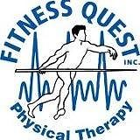

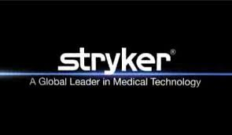

Surgery Center at St. Andrews 



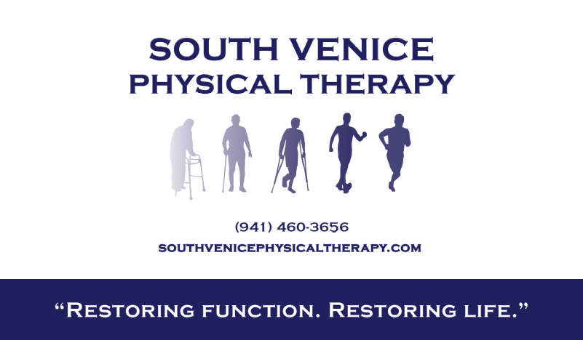

DISCLOSURE

To ensure balance, independence, objectivity and scientific rigor in all sponsored educational activities, all participating speakers, course directs and planning committee members are required to disclose to the program audience any financial relationships related to the subject matter of this program. Relationships of spouse/partner with proprietary entities producing health care goods or services should be disclosed is they are of a nature that may influence the objectivity of the individual able to control the content of the program. Specific disclosure information for each speaker, course director and planning committee member will be shared with the audience prior to the speaker’s presentation.

